**SQL (Structured Query Language)**

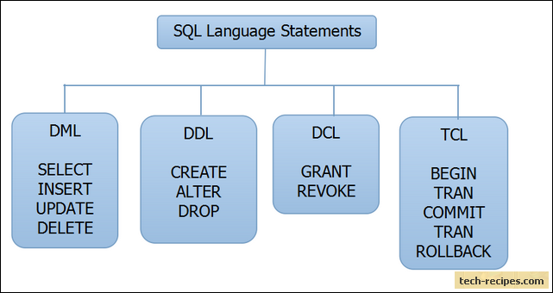

* CREATE
  + create database practise;
  + create table books (id int not null auto_increment, author varchar(255), title varchar(255), publication_year int, primary key(id));
* INSERT
  + insert into books values (8, ‘David Baldacci’, ‘Camel Club’, 2005);
* SELECT
  + select * from books;
  + select * from books where publication_year < 2000;
* UPDATE
  + update books set publication_year=2018 where id=1;
* DELETE
  + Delete books where id=1;
* LOAD
  + load data infile '/var/lib/mysql-files/books.csv' into table books fields terminated by ',' lines terminated by '\n';

Ref: <https://stackoverflow.com/questions/32737478/how-should-i-tackle-secure-file-priv-in-mysql>

* EXPORT
  + select * into outfile '/var/lib/mysql-files/books_out.csv' FIELDS TERMINATED BY ',' LINES TERMINATED BY '\n' from books;

Ref:

<https://stackoverflow.com/questions/467452/dump-a-mysql-database-to-a-plaintext-csv-backup-from-the-command-line>

* COPY TABLE DEFINITION
  + create table books2 like books;
* CREATE TABLE ON-THE-FLY
  + create table books3 select * from books;
* DROP
  + drop table books;
  + drop database practise;